## **Security Groups in AWS**

Suppose you want to access an EC2 instance after a few days or shut off the laptop/system and start again.

As of now you all are aware that your laptop ip address is dynamic and it changes when you shut off the laptop and start again.

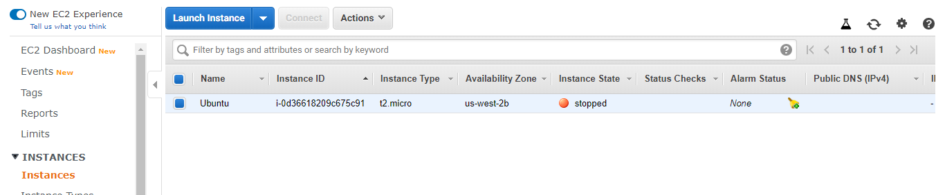

Please remember to set your **Security Group Inbound Rule to MyIP each time you start your EC2 instance**. There should be only one row in your inbound rules.

Edit the inbound rules: scroll down and click to security group name - **ml sec** 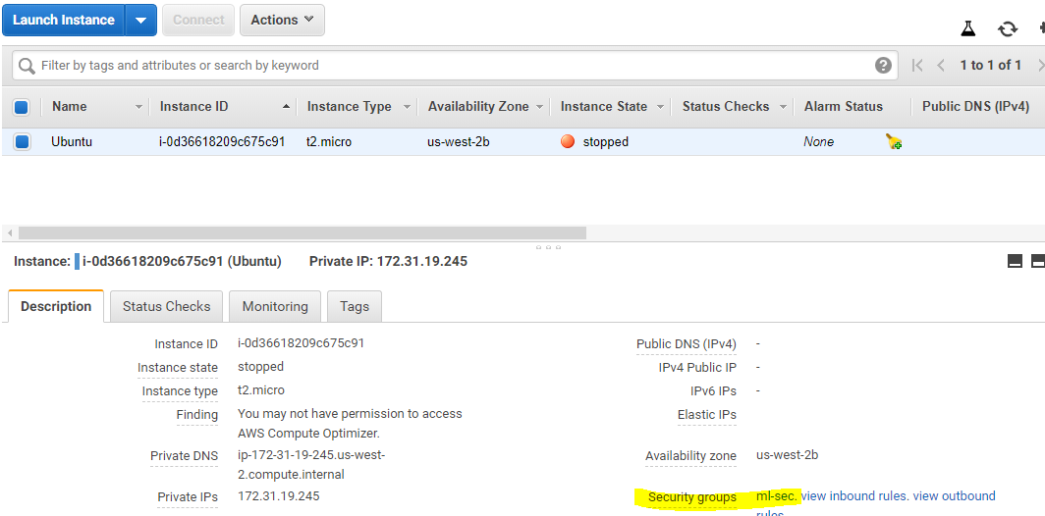

1. Click on **Inbound rules** tab > click on **Edit inbound rules**

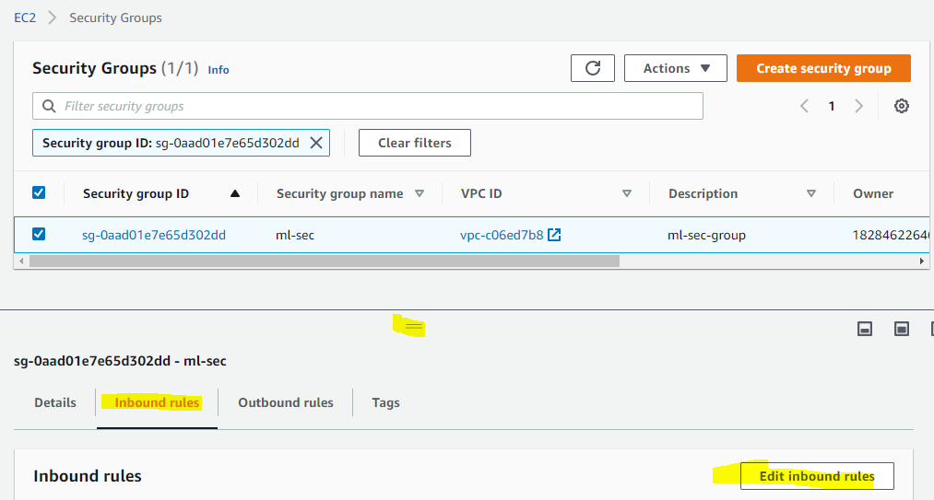

1. Again click on My IP and **Save rules**. Verify that the IP is changed.

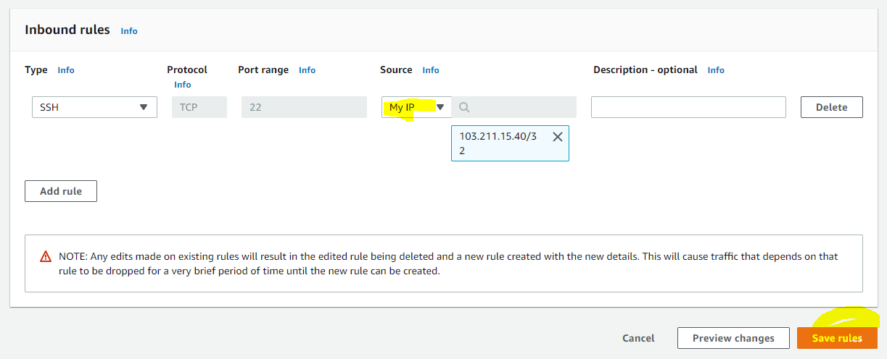

1. Verify with the link below.  
   <https://www.ip2location.com/>

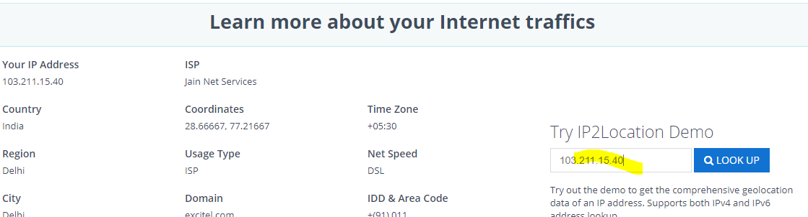

1. After you close the Edit box for Inbound Rules, this MyIP rule will automatically change to “**Custom**”, with the corresponding IP that it has picked up when you clicked on “**MyIP**”. This is normal behaviour.

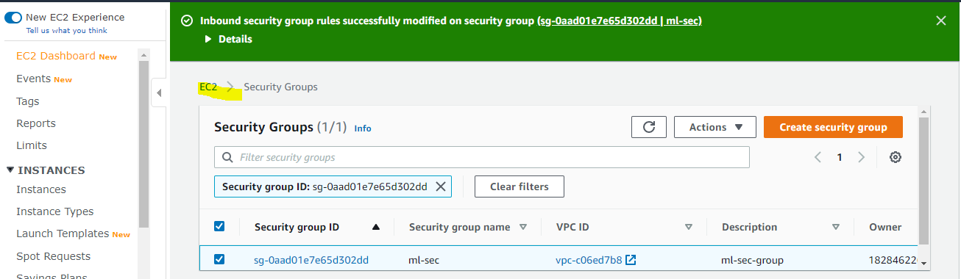

1. Now, go back to EC2 dashboard and start the EC2 instance and access from PuTTy or Mac/Linux system.
2. Copy **public DNS** from dashboard.

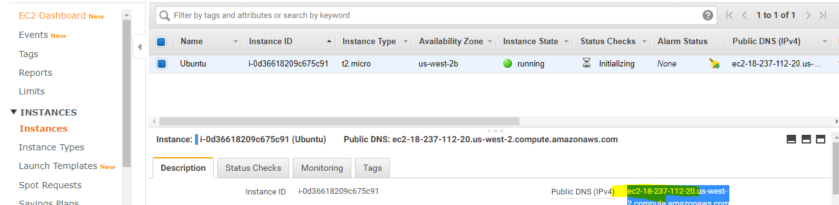

1. Open PuTTy:  
   Under the ‘**Host Name**’ section, paste the public DNS information of your instance that you just copied.

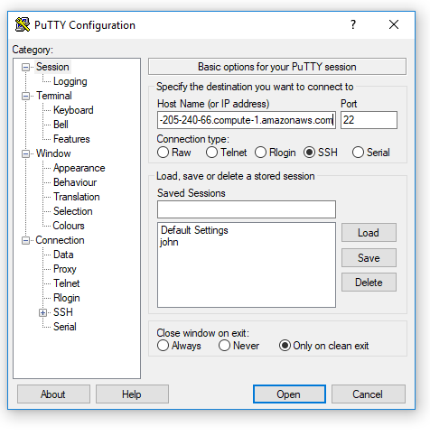

1. On the left-hand side panel, click on ‘**Connection**’. Then click on ‘**SSH**’ followed by ‘**Auth**’. In the private key field, click on **‘Browse’**.

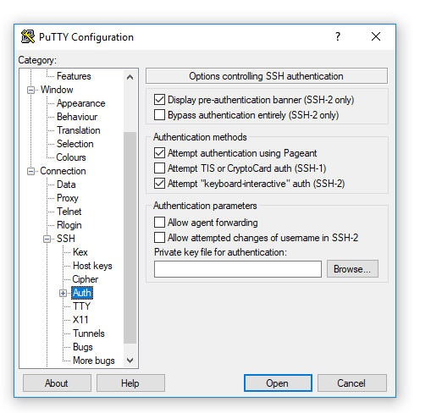

1. Select the .ppk file(**Test_1.ppk**) you generated using PuTTYgen and click on ‘**Open**’.

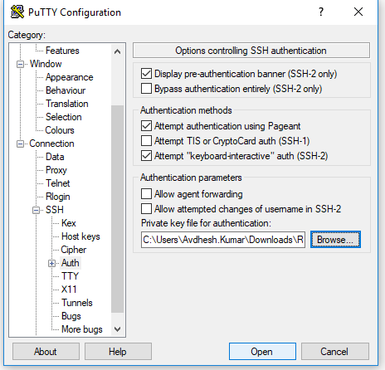

1. Click on ‘**Yes’**. and login with **ec2-user**.

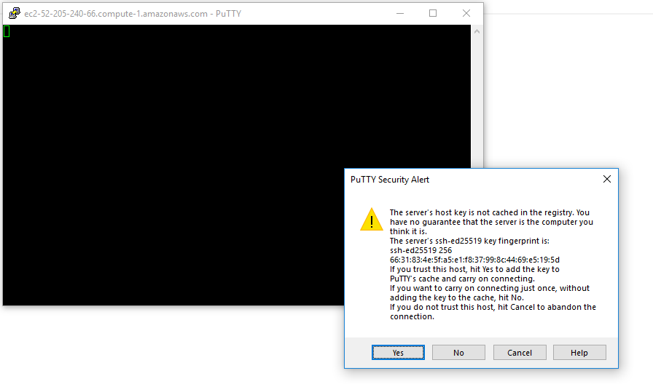

**Note:** In case you faced any issue- Network connection time out, then please check SSH port 22 with **My address** inside the security.